|  |
| --- |
|  |
| OrgPortal |
| Wireframes |
|  |
| **Jerry Falconer** |
| **2/10/2014** |

* 1. Home

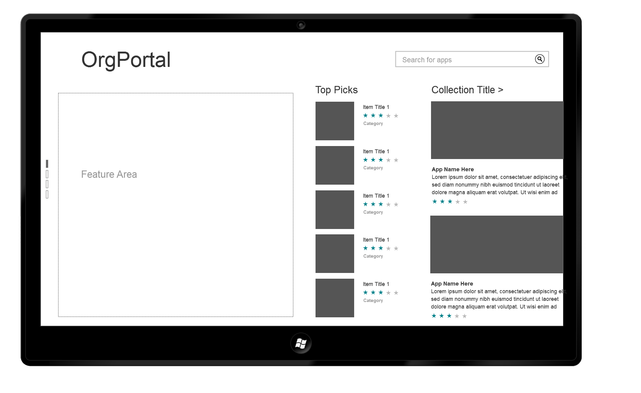

* 1. Home Scroll Vertical

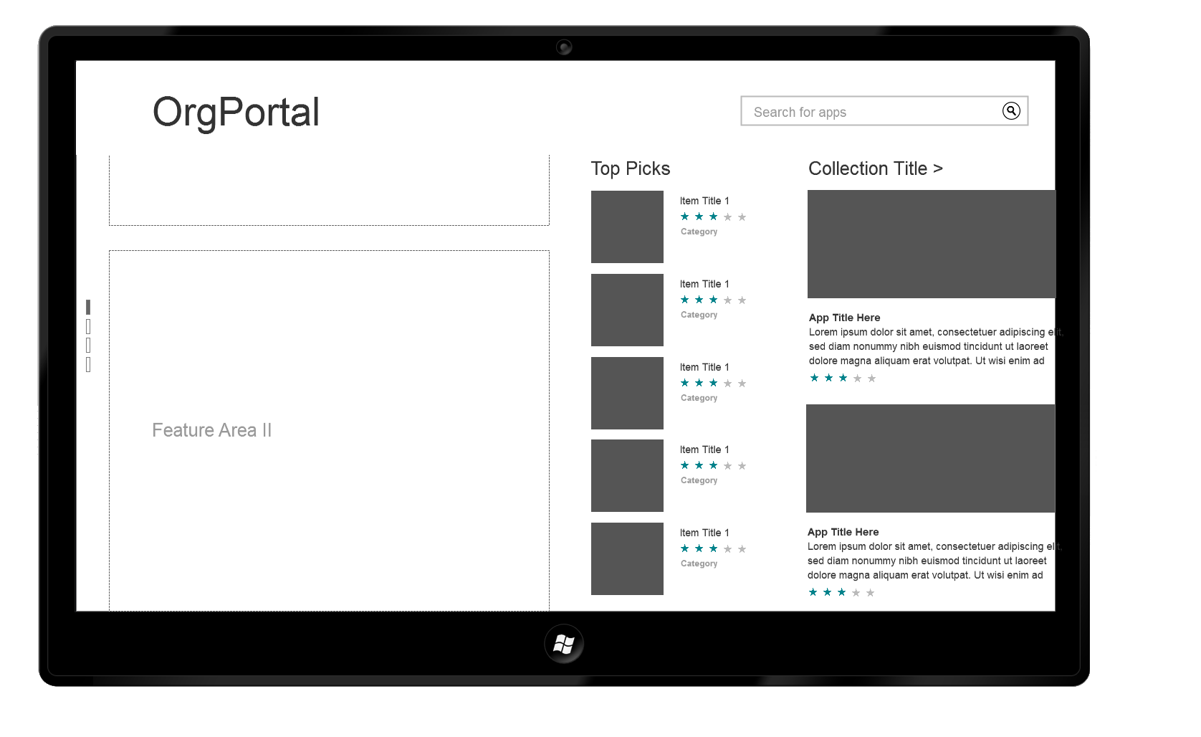

* 1. Home Scroll Right

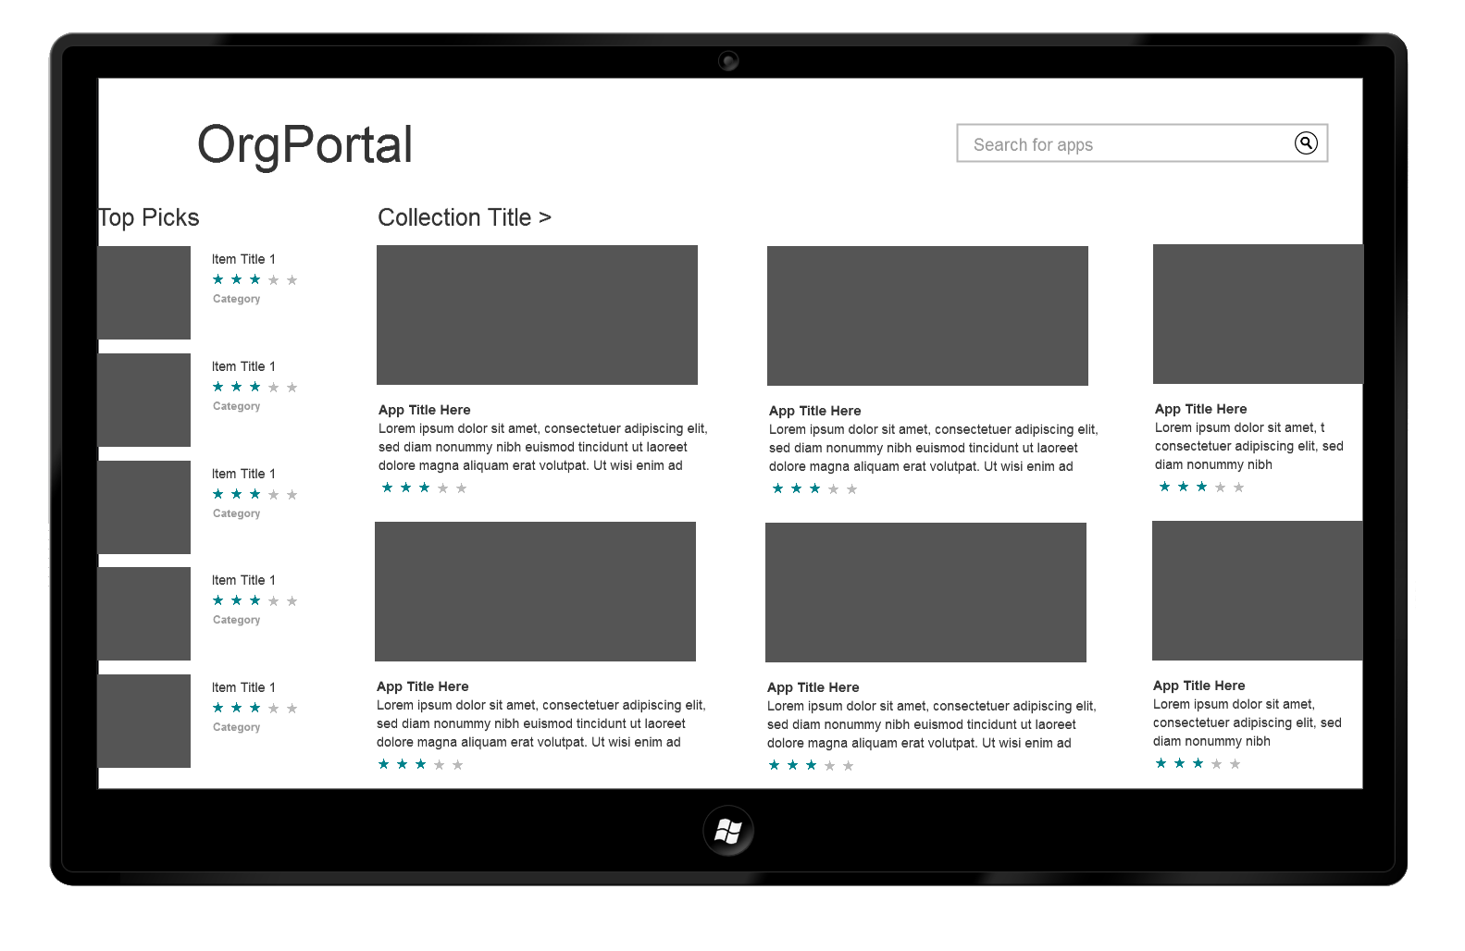

* 1. App

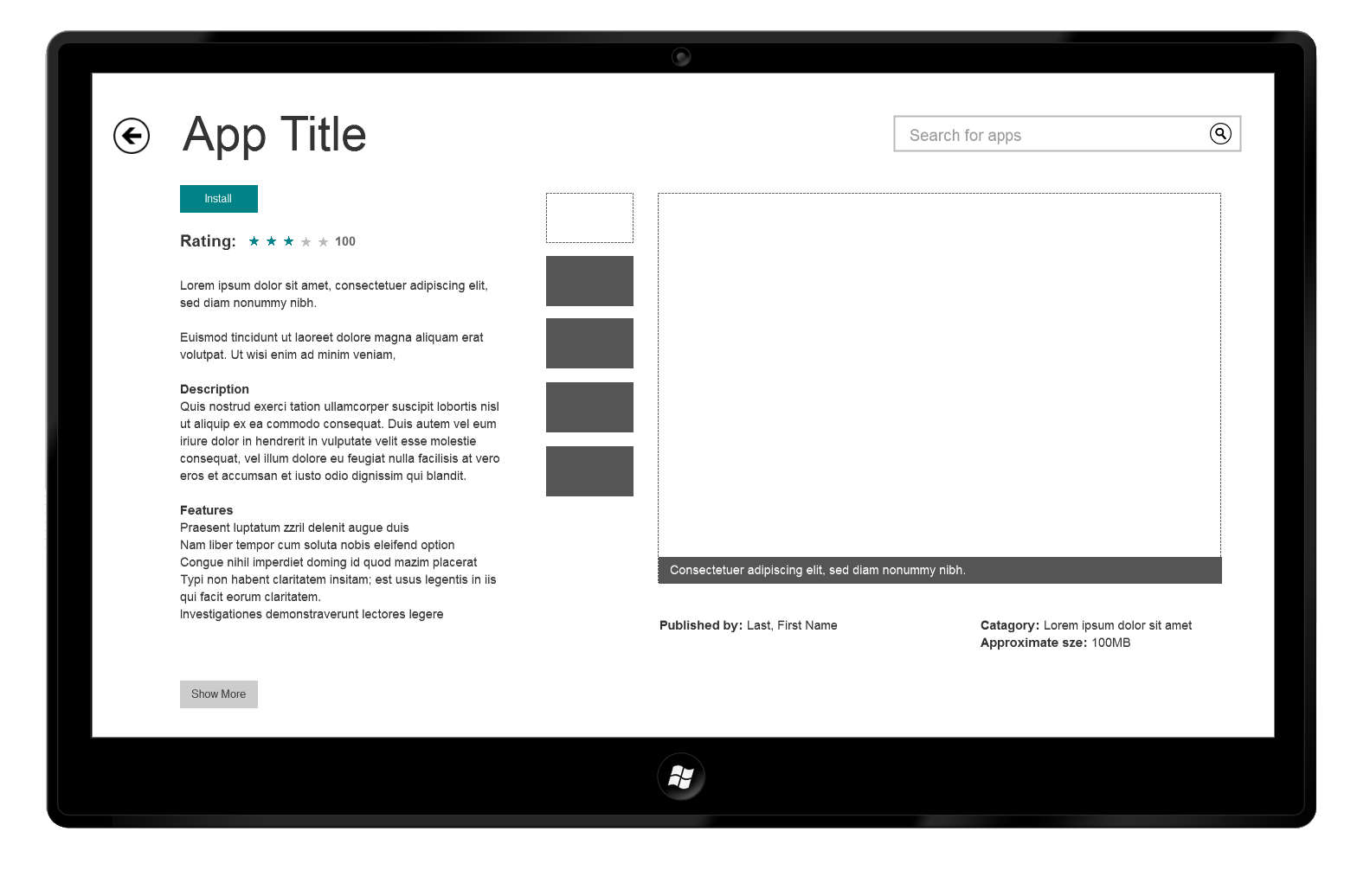

* 1. Installing

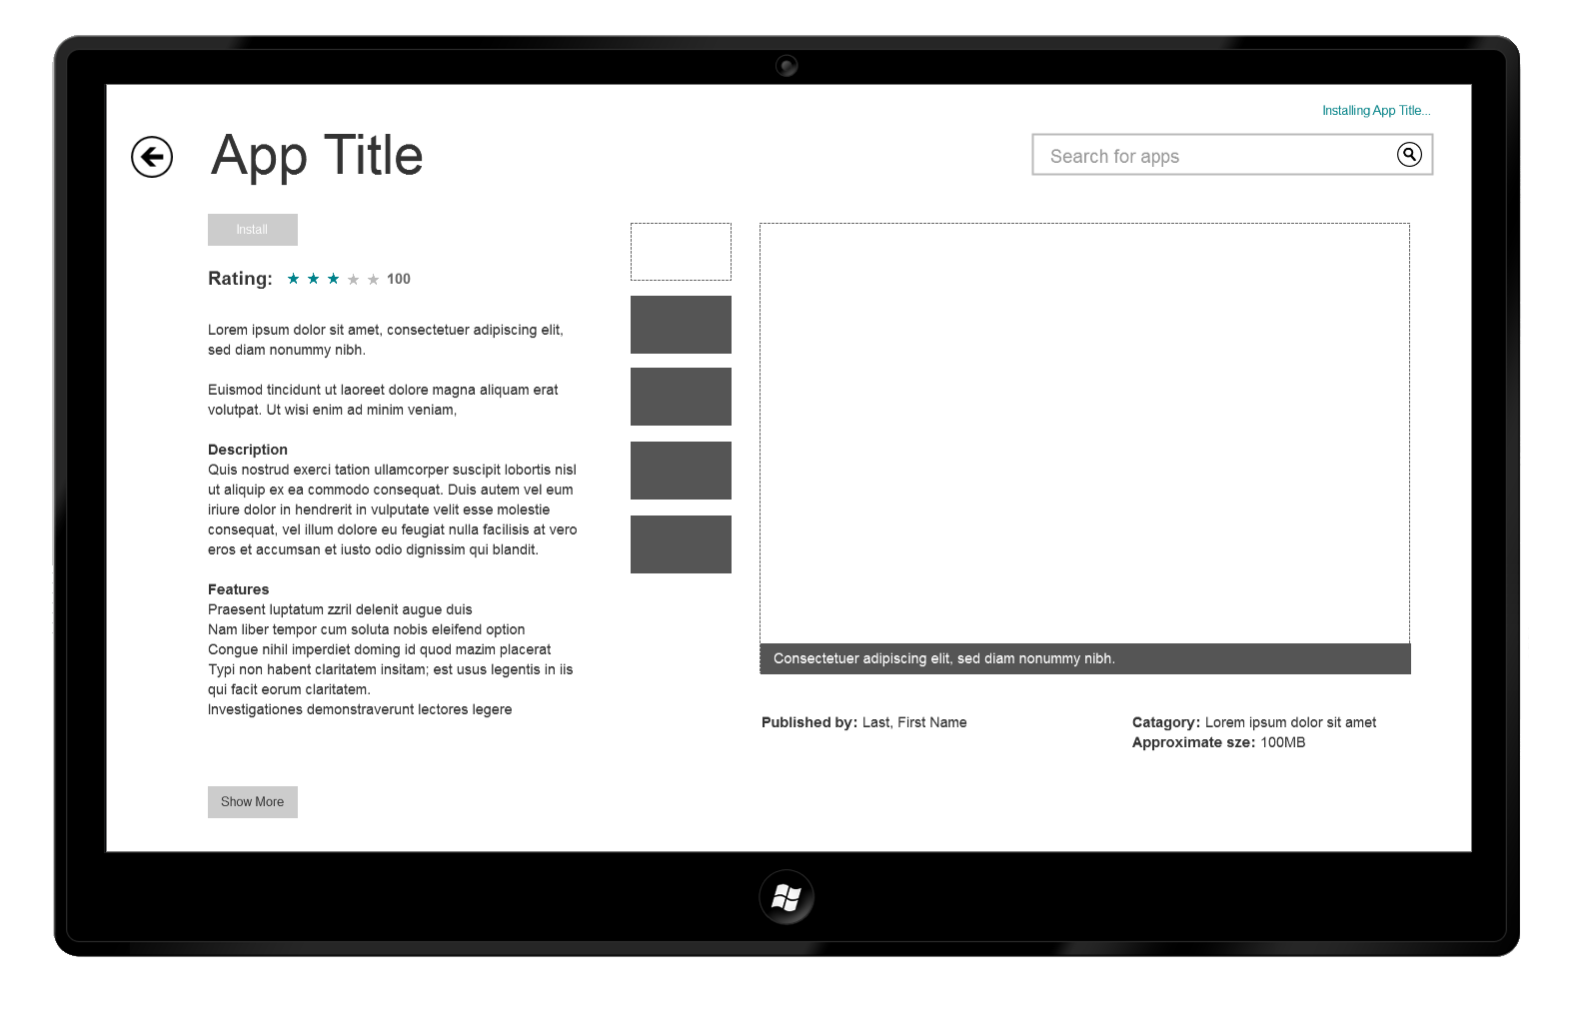

* 1. Installed

